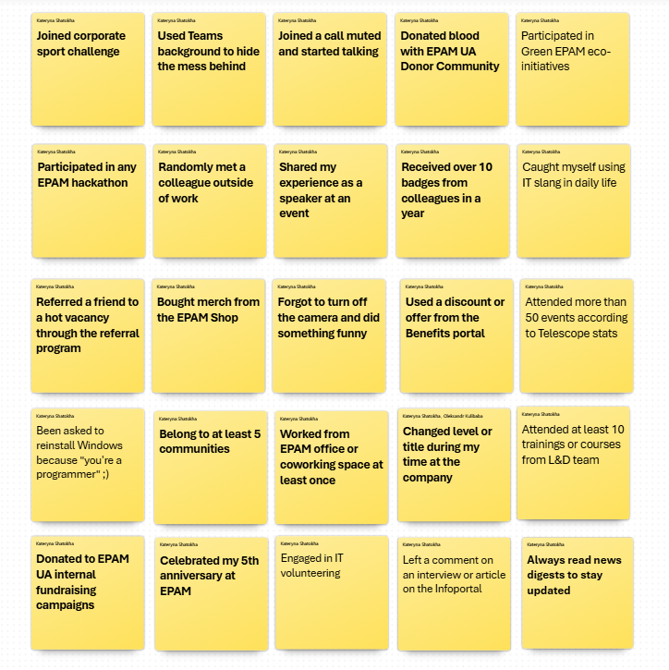
Type: One-pager
Header: EPAM Universe Bingo: Chart Your Cosmic Path
Game Design Document
Mechanics: Bingo
Style: Starfleet / Cosmic Exploration
Key Features and Gameplay Mechanics
- Bingo Board Layout:
  - The game interface includes a 5x5 grid (25 cells in total).
  - Each cell contains a unique statement or task related to the theme.
- Cell Selection and Highlighting:
  - Players can select a cell by clicking on it.
  - Upon selection, the cell is highlighted with a green glow, indicating it has been chosen.
- Toggle Functionality:
  - Allows players to unselect a cell if they change their mind.
  - The green highlight is removed upon deselection.
- Line Completion Recognition:
  - When players complete a full line (vertically, horizontally, or diagonally), the entire line is highlighted in neon.
  - This serves as a visual indication of progress.
- Score System:
  - Per Cell: Each highlighted cell grants the player 1 point.
  - Line Bonus: Completing a line (vertically, horizontally, or diagonally) earns the player an additional 5 points.
  - Players can complete multiple lines to accumulate bonus points.
- Max Score Cap:
  - The maximum achievable score is 85 points.
- Result Submission:
  - Once players finish selecting cells, they click the “Get Result” button to finalize their playthrough.
- Dynamic Feedback:
  - Scores are tallied, and based on the total points earned, players receive a unique “character profile” or “cosmic persona.”
- Pop-Up or On-Page Display:
  - A separate popup window or a section beneath the bingo grid displays the player’s result.
  - Each result includes:
    - Title: The name of the persona earned.
    - Description: A short narrative reflecting the player’s cosmic path.
    - Illustration: An image representing the persona (optional).

Additional Suggestions for Completion
Thematic Music and Sound Effects (optional):
  - Cosmic-themed background music and sound effects for interactions (e.g., cell selection, line completion).
Multiplayer Mode (Optional):
  - Introduce a leaderboard or challenge mode where players can compare scores with others.
Shareable Results and Social Integration:
  - Provide a sharing option for players to showcase their results on social media (e.g., "I scored 70 points and became a Galactic Voyager in EPAM Universe Bingo!").
Mobile Optimization:
  - Ensure the interface adjusts seamlessly to various screen sizes for mobile and tablet users.
Error Handling:
  - Create clear error messages for cases such as double-clicking "Get Results" or technical issues.
Tutorial or Instructions Section:
  - Add a brief “How to Play” overlay or button for first-time users to understand the rules easily.

Technical Details
- Platform: Web-based (HTML5/CSS3/JavaScript, React or other modern frameworks).
- Graphics: Simple, space-themed design with neon accents for the aesthetics.
- Performance: Lightweight and optimized for smooth gameplay across devices.

Characteristics according to the score
1-10 Novice Explorer
You are embarking on your first voyage through the vast universe of endless opportunities. Ahead of you lies a galaxy filled with uncharted adventures: from unexpected "transmission glitches on calls" to shining stars of success! Stay vigilant, navigate cautiously, and unlock the secrets of how this cosmic world operates. 🚀✨
11-20 Rising Star
You’ve already settled in and even caught glimpses of brilliance as a proud member of the star fleet. Your cosmic logbook is starting to fill with the first marks of experience, and you’re no longer just a passenger — you’re becoming a skilled navigator of this vast universe. Keep charting your stellar map with new milestones and pave the way to infinity and beyond. 🌌🚀✨
21-30 Lightspeed racer
Your efficiency inspires admiration! You glide between activities as effortlessly as energy flows between the stars. Your presence at corporate events and within communities has become a tradition. The company’s culture isn’t just your work — it’s part of your very orbit. You’ve surrounded yourself with fascinating individuals, much like Saturn is encircled by its moons, and your calendar is confidently packed with interstellar events. 🌌🚀✨
31-40 Galactic Champion
You are a versatile crew member in every aspect of corporate life, with your calendar seemingly booked for an entire year across parallel universes. You stand at the very heart of all epic missions, where your experience, creativity, and dedication inspire colleagues across the cosmos. Even when it feels like everything has been achieved, you discover new horizons waiting to be explored. 🚀🌌✨
40+ The Legend of the EPAM Universe
Wow… You’re not just an EPAM-er — you’re a cosmic legend! No one knows exactly how you did it, but it seems like you’re present across every corner of the galaxy. You’ve been part of every mission, ignited stars in countless hearts, carried out an infinite number of activities, and guided rookies through their most daring space quests. You’ve become an integral part of the company’s legacy. Your potential is as limitless as the universe itself. 🌌🚀✨
Statements
Joined corporate sport challenge
Used Teams background to hide the mess behind
Joined a call muted and started talking
Donated blood with EPAM UA Donor Community
Participated in Green EPAM eco-initiatives
Participated in any EPAM hackathon
Randomly met a colleague outside of work
Shared my experience as a speaker at an event
Received over 10 badges from colleagues in a year
Caught myself using IT slang in daily life
Referred a friend to a hot vacancy through the referral program
Bought merch from the EPAM Shop
Forgot to turn off the camera and did something funny
Used a discount or offer from the Benefits portal
Attended more than 50 events according to Telescope stats
Was asked to reinstall Windows because 'you're a programmer' :)
Belong to at least 5 communities
Have worked from an EPAM office or coworking space at least once
Changed level or title during my time at the company
Attended at least 10 trainings or courses provided by the L&D team
Donated to EPAM UA internal fundraising campaigns
Celebrated my 5th anniversary at EPAM
Engaged in IT volunteering
Left a comment on an interview or article on the Infoportal
Always read news digests to stay updated

